**Project Design Phase-II**

**Data Flow Diagram & User Stories**

|  |  |
| --- | --- |
| Date | 05/11/22 |
| Team ID | PNT2022TMID37201 |
| Project Name | Project – Smart Farmer-IoT Enabled Smart Farming Application |
| Maximum Marks | 4 Marks |

**Data Flow Diagrams:**

A Data Flow Diagram (DFD) is a traditional visual representation of the information flows within a system. A neat and clear DFD can depict the right amount of the system requirement graphically. It shows how data enters and leaves the system, what changes the information, and where data is stored.

**Example:** [**(Simplified)**](https://developer.ibm.com/patterns/visualize-unstructured-text/) **EXAMPLE: DFD Level0 Farmer-IoT Enabled Smart Farming**

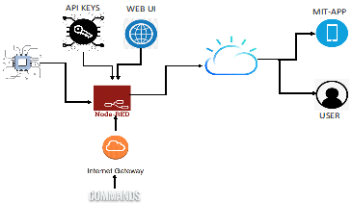 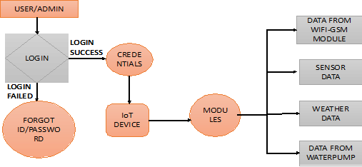

**User Stories**

Use the below template to list all the user stories for the product.

| **User Type** | **Functional Requirement (Epic)** | **User Story Number** | **User Story / Task** | **Acceptance criteria** | **Priority** | **Release** |
| --- | --- | --- | --- | --- | --- | --- |
| Customer (Mobile user) | Registration | USN-1 | As a user, I can register for the application by entering my email, password, and confirming my password. | I can access my account / dashboard | High | Sprint-1 |
|  |  | USN-2 | As a user, I will receive confirmation email once I have registered for the application | I can receive confirmation email & click confirm | High | Sprint-1 |
|  |  | USN-3 | As a user, I can register for the application through Gmail |  | Medium | Sprint-1 |
|  | Login | USN-4 | As a user, I can log into the application by entering email & password |  | High | Sprint-1 |
|  | Dashboard | USN-5 | As a user, I can see the information in one unified location | I can access my account information | High/Medium | Spirnt-1 |
| Customer (Web user) | Login | USN-6 | As a user, I can able to access my application in another device | I can access my account | High | Sprint-2 |
|  | Dashboard | USN-7 | As a user, I can able to view the information | I can access the dashboard | High | Sprint-2 |
| Customer Care Executive | Requirement/External Support | USN-8 | As a customer care executive, I am the responsible for clearing the doubts to the customers | I can receive details from customers | High | Sprint-2 |
|  | Login | USN-9 | As a customer care executive, I can login to the customer account and give feedback, issues to the customer | I can solve the customer issues | High/Medium | Sprint-2 |
| Administrator | Login | USN-10 | As a administrator, I can manage the username and password | Customer can login to account | High | Sprint-1 |
|  |  |  |  |  |  |  |
|  |  |  |  |  |  |  |